

Land Information Ontario (LIO) Warehouse

Data Class Name: Miscellaneous Line

Documentation

Produced by: Information Access and Information Management Policy Unit

Ministry of Natural Resources and Forestry

Date: July 27, 2015

**Purpose**

This document provides additional information to support the use of geospatial data. The Physical Model Diagram provides a visual representation of the relationships in the data class. The Data Change History lists all the modelling and access changes that have occurred during the lifecycle of the data class. A data description identifying table and field names is available upon request.

**Need Assistance?**

Please contact LIO Support at [lio@ontario.ca](mailto:lio@ontario.ca) or 705-755-1878 if you require help.

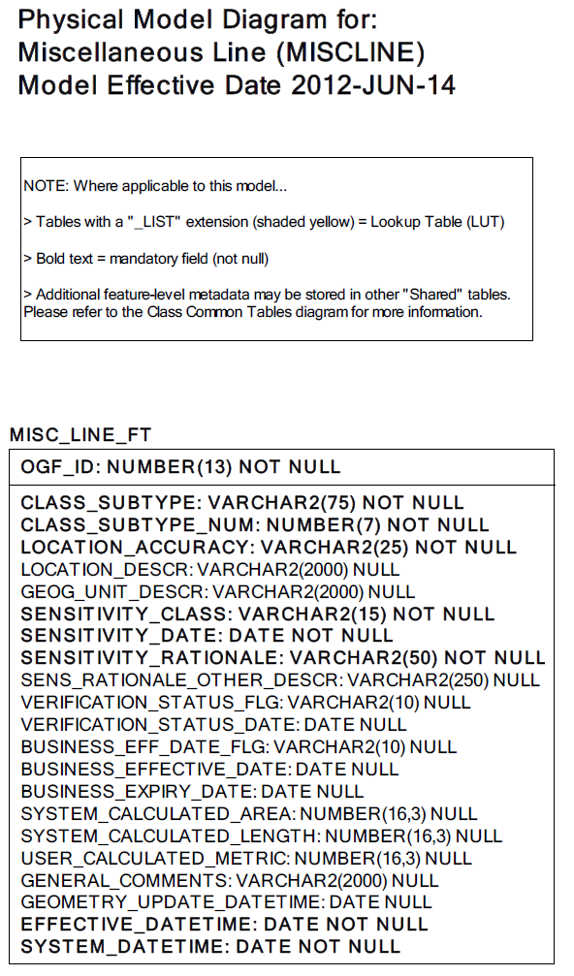  
Data Class Change History

Data Class Name: Miscellaneous Line  
  
Data Class Short Name: MISCLINE

| Date  YYYY-MM-DD | Details of Change |
| --- | --- |
| **2014** | Retired – no longer maintained or supported |
| **2008** | Data Class Description Change:  Received new description from BDI |
| **2003** | Converted to Simple Data Class with the following table added:  - GEOG_UNIT  - JUSTIFICATION  - EXTERNAL_REFERENCE |
| **2002** | Converted to Structured Data Class. |
| **1996** | NEW Data Class to hold former Ontario Base Map (OBM) features. |

**Data Description**  
Please refer to the metadata record for the data description..